Date:15/10/2026
CO1-Assessment Tool-3
CODING CHALLENGE
Course Code : DSA0308
Course Name : Natural Language Processing

Name : G.Pallavi Reg No : 192472203

1.Email and Password Validator

Aim: To write a Python program to validate an email address, password, and mobile number using regular expressions.

Problem Statement
Develop a Python program using regular expressions to validate email addresses, passwords, and mobile numbers according to specified rules.

Algorithm
- Import the re module.
- Get email, password, and mobile number from the user.
- Check the email format using a regular expression.
- Check the password for uppercase, lowercase, digit, special character, and minimum length.
- Check whether the mobile number contains 10 digits and starts with 6–9.
- Display the validation results.

Code :
import re
email = input("Enter email: ")
password = input("Enter password: ")
mobile = input("Enter mobile number: ")
if re.match(r'^[A-Za-z][A-Za-z0-9._]*@[A-Za-z]+\.(com|org|edu|net|in)$', email):
print("Valid Email")
else:
print("Invalid Email")
if re.search(r'^(?=.*[A-Z])(?=.*[a-z])(?=.*\d)(?=.*[@#$%&!]).{8,}$', password):
print("Strong Password")
else:
print("Weak Password")
if re.match(r'^[6-9]\d{9}$', mobile):
print("Valid Mobile Number")
else:
print("Invalid Mobile Number")

Output :
Enter email: pallavi123@gmail.com
Enter password: Pallavi@123
Enter mobile number: 9876543210
Valid Email
Strong Password
Valid Mobile Number

Screenshort of output :

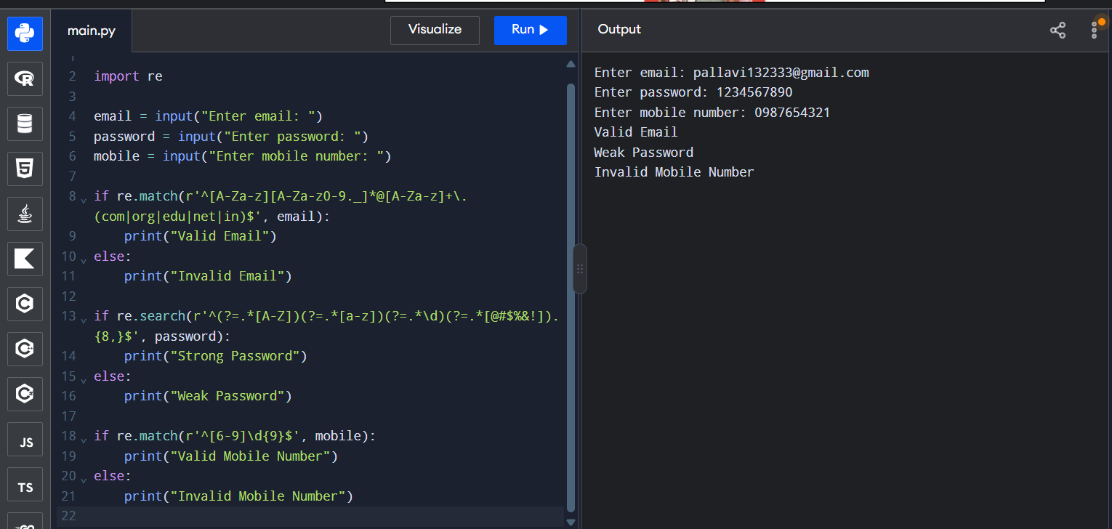

Result: Thus, the Python program to validate email, password, and mobile number using regular expressions was executed successfully.

2. Finite State Automata (DFA) Simulator

Aim: To write a Python program to simulate a Deterministic Finite Automaton (DFA) that accepts strings ending with ab.
Problem Statement
Develop a Python program to simulate a DFA. It should process input strings using state transitions and display whether each string is accepted or rejected.
Algorithm
Initialize the starting state as q0.
Read a string containing a and b.
Process each character and change the state according to the transition rules.
Display the transition path.
If the final state is q2, print Accepted; otherwise, print Rejected.

Code :
def check(s):
state = "q0"
path = [state]
for ch in s:
if state == "q0":
state = "q1" if ch == 'a' else "q0"
elif state == "q1":
state = "q2" if ch == 'b' else "q1"
else:
state = "q1" if ch == 'a' else "q0"
path.append(state)
print("Path:", " -> ".join(path))
if state == "q2":
print("Accepted")
else:
print("Rejected")
s = input("Enter string (a,b): ")
check(s)

Output :
Enter string (a,b): abab
Path: q0 -> q1 -> q2 -> q1 -> q2
Accepted

Screenshort of output :
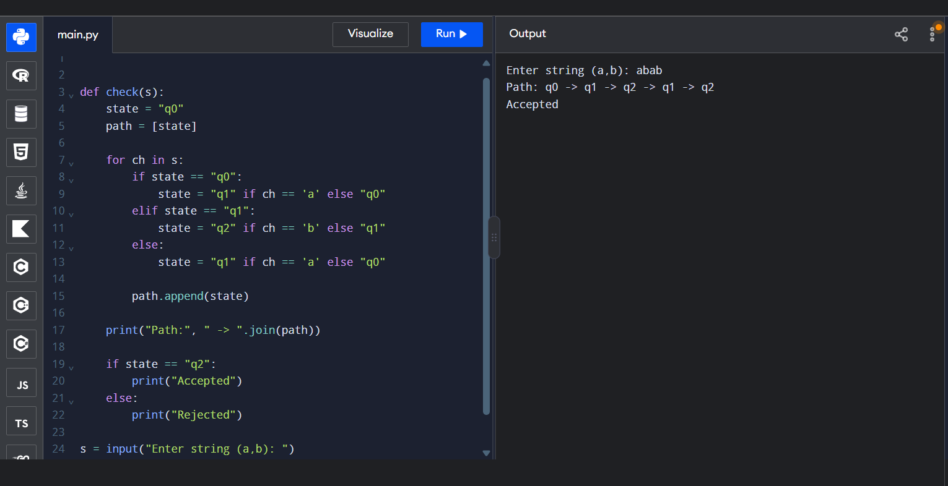
Result: Thus, the Python program to simulate a DFA for strings ending with ab was executed successfully.

3. Smart Pattern Matching Engine Using Regular Expressions
Aim
To write a Python program to search for dates, phone numbers, hashtags, mentions, prefixes, and suffixes in a text using regular expressions.
Problem Statement
Develop a Python program using regular expressions to search for dates, phone numbers, hashtags, mentions, prefixes, and suffixes in text.
Algorithm
Import the re module.
Store the sample text.
Use regular expressions to find dates and phone numbers.
Search for hashtags and mentions.
Search for words with the specified prefix and suffix.
Display all matching patterns.

Python Program

import re
text = """Meeting on 12/09/2026
Call 9876543210
#NLP
@OpenAI
natural language processing"""
print("Dates:", re.findall(r'\b\d{2}/\d{2}/\d{4}\b', text))
print("Phones:", re.findall(r'\b[6-9]\d{9}\b', text))
print("Hashtags:", re.findall(r'#\w+', text))
print("Mentions:", re.findall(r'@\w+', text))
print("Prefix:", re.findall(r'\bnatural\w*', text))
print("Suffix:", re.findall(r'\b\w+ing\b', text))

Output :
Dates: ['12/09/2026']
Phones: ['9876543210']
Hashtags: ['#NLP']
Mentions: ['@OpenAI']
Prefix: ['natural']
Suffix: ['Meeting']

Screenshort of output :

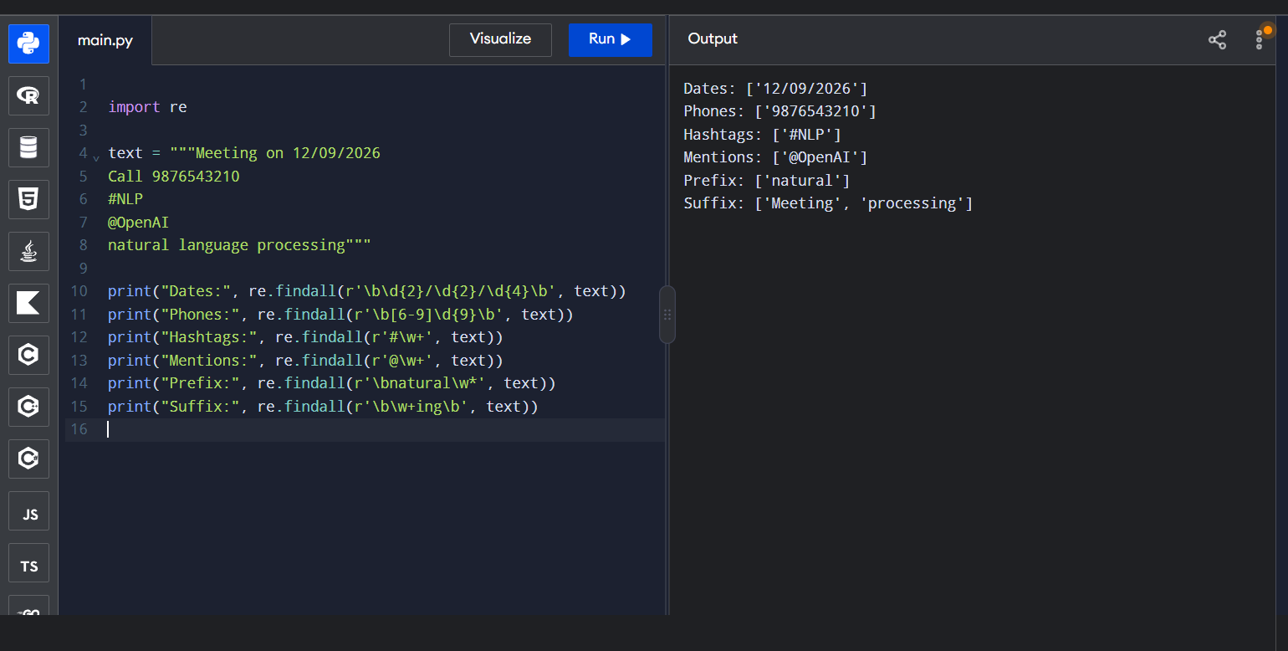

Result: Thus, the Python program to perform smart pattern matching using regular expressions was executed successfully.

